IB Pre-Calculus Summer Assignment-Fall 2016
Mrs. Mary Ruff
mary.ruff@pueblocityschools.us

Greetings! I hope that you all are getting ready to enjoy your summer and refresh yourselves for the coming year. I know that summer break always gives me the chance to reenergize for the next school year. For those of you whom I have not yet met, I look forward to getting to know you and to work with you this upcoming school year. We have so much exciting mathematics to learn and this assignment should help us to be able to get right to it.
This course follows the International Baccalaureate Math Methods Standard Level syllabus. Topics include number theory and algebra, descriptive statistics, probability, statistical applications, trigonometry, vectors, and calculus. It is important that the content on this summer assignment be understood before the start of the IB Pre-Calculus course. All topics here are considered Presumed Knowledge and could be used on the IB exam.
What this really means is that the content on this assignment is math that you already know how to do. It is expected that you will refresh yourself on this material before class starts. If there are things that you have difficulty with, you are responsible for seeking help. You may choose to form study groups, use resources such as khanacademy.org, use books, or email me. When we return to school, there will be a quiz over the material within the first several days. Come prepared to ask questions over any concepts that you were unable to master!
In addition, you will be using a Texas Instrument (TI-84) graphing calculator. There is a class set available for use during class time, but these cannot be checked out to individual students. Often times, you will need a calculator to use at home. It is strongly recommended that you purchase a calculator of your own since they are required for the IB exam and are allowable for use on both the ACT and SAT. Additionally, many college mathematics courses require this calculator. As these calculators run from $90-$120, (possibly less on Amazon.com or eBay) some families find that purchasing one is not a possibility. There is now another free option if you have an Android device. There is a TI-84 Graphing Calculator APP called Wabbitemu. I am attaching instructions that walk you through how to set up the app on your device. If you are unable to install the app or purchase a calculator, please see me privately or email me so that we can discuss other options.
I am also attaching instructions on signing up for a Remind account for this course. This will allow me to send you a reminder during the summer to complete your assignment and will also be used as a way for us to communicate throughout the 2016-2017 school year.
Attached you will find the assignment and the instructions for Remind and wabbitemu. Thank you and have a wonderful summer!

Summer Checklist
- Sign up for Khan Academy
- You MUST sign up using the attached instructions so that I can see your progress.
- Sign up for Remind
- Download the Wabbitemu App
- Complete Khan Academy work

Instructions for Installing the Wabbitemu
- Search for Wabbitemu on the PLAY store or on the Apple App Store
- Install
- Open
- Choose “Help me create a ROM using open source software”
- Click NEXT at bottom of screen (this button is kind of hard to see)
- Choose TI-84 Plus SE
- Click NEXT
- Choose “I’d like to download one”
- Click FINISH
Yay!!! You are all set to turn on and use your TI 84 calculator!! It functions EXACTLY like our classroom devices!

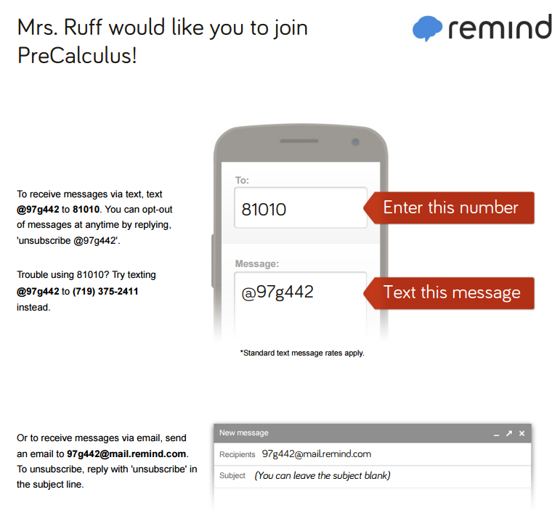
Instructions for Signing up for Remind

YMQBS4
How to join your teacher’s Khan Academy class

Sign up at
khanacademy.org
(
or log in if you already have an account
).
Visit
khanacademy.org/coaches
(
the “Coaches” tab in your profile
).
In the “Add a coach” field, enter the class code.
Class code: _______________
You’re set. Now click
Home
to start learning!
1.
2.
3.
4.
Khan Academy Work Checklist
- Go to the Subjects drop-down menu on the upper left side of the screen
- Choose Algebra
- Choose Algebra Basics, then Foundations
- Complete all of the practice problems in the following sections:
- The square root
- Fractions
- Choose Two-variable Linear Equations
- Complete all of the practice problems in the following sections:
  - Ordered-pair solutions to two-variable linear equations
  - x-intercepts and y-intercepts
  - Slope
  - Slope-Intercept Form
- Choose Quadratic Equations
- Complete all of the practice problems in the following sections:
- Solving Quadratic Equations by taking the square root
- Solving Quadratic Equations by factoring
- Choose Systems of Linear Equations
- Complete all of the practice problems in the following sections:
- Graphical representation of systems of equations
- Equivalent Systems of equations and the elimination method
- Solving Systems of equations with substitution
- Choose Two-variable linear inequalities
- Complete all of the practice problems in the following sections:
- Checking solutions of two-variable inequalities
- Constraining solutions of two-variable inequalities
If you have difficulties, you can watch videos for help on any of the sections as you go along.

