Practice for Quadratics
1a. [3 marks]
A quadratic function can be written in the form 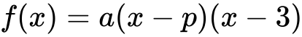. The graph of has axis of symmetry 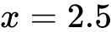 and -intercept at
Find the value of .
1b. [3 marks]
Find the value of .
1c. [8 marks]
The line 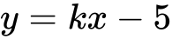 is a tangent to the curve of . Find the values of .
2a. [2 marks]
Let 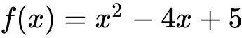.
Find the equation of the axis of symmetry of the graph of .
2b. [4 marks]
The function can also be expressed in the form 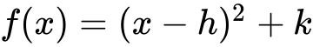.
(i) Write down the value of .
(ii) Find the value of .
3a. [2 marks]
Consider 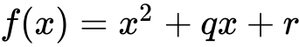. The graph of has a minimum value when 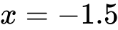.
The distance between the two zeros of is 9.
Show that the two zeros are 3 and 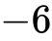.
3b. [4 marks]
Find the value of and of .
4a. [2 marks]
The following diagram shows part of the graph of a quadratic function .
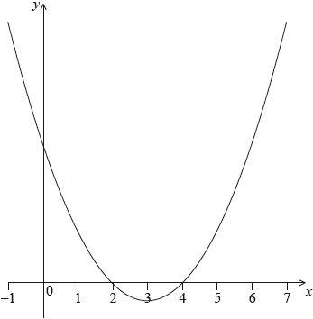
The vertex is at and the -intercepts at 2 and 4.
The function can be written in the form .
Write down the value of and of .
4b. [2 marks]
The function can also be written in the form 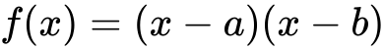.
Write down the value of and of .
4c. [2 marks]
Find the -intercept.
5a. [2 marks]
Let 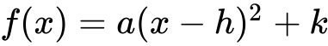. The vertex of the graph of is at 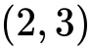 and the graph passes through 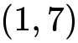.
Write down the value of and of .

5b. [3 marks]
Find the value of .
6a. [2 marks]
Let 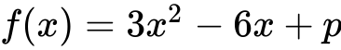. The equation 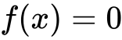 has two equal roots.
Write down the value of the discriminant.
6b. [1 mark]
Hence, show that 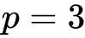.
6c. [4 marks]
The graph of has its vertex on the -axis.
Find the coordinates of the vertex of the graph of .
6d. [1 mark]
The graph of has its vertex on the -axis.
Write down the solution of .
6e. [1 mark]
The graph of has its vertex on the -axis.
The function can be written in the form . Write down the value of .
6f. [1 mark]
The graph of has its vertex on the -axis.
The function can be written in the form . Write down the value of .
6g. [1 mark]
The graph of has its vertex on the -axis.
The function can be written in the form . Write down the value of .
6h. [4 marks]
The graph of has its vertex on the -axis.
The graph of a function is obtained from the graph of by a reflection of in the -axis, followed by a translation by the vector 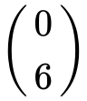. Find , giving your answer in the form 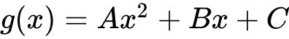.
7. [6 marks]
The equation 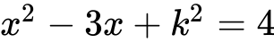 has two distinct real roots. Find the possible values of k .
8. [7 marks]
Consider the equation 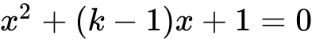 , where k is a real number.
Find the values of k for which the equation has two equal real solutions.
9a. [1 mark]
Let be a quadratic function. Part of the graph of is shown below.
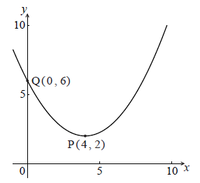
The vertex is at P(, ) and the y-intercept is at Q(, ) .
Write down the equation of the axis of symmetry.
9b. [2 marks]
The function f can be written in the form .
Write down the value of h and of k .
9c. [3 marks]
The function f can be written in the form .
Find a .
10a. [4 marks]
Let 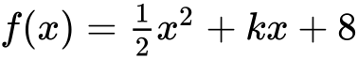 , where 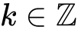 .
Find the values of k such that has two equal roots.
10b. [4 marks]
Each value of k is equally likely for 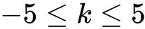 . Find the probability that has no roots.
11a. [2 marks]
The following diagram shows part of the graph of a quadratic function f .
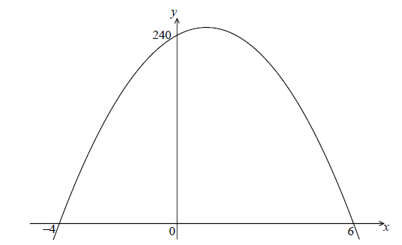
The x-intercepts are at 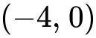 and 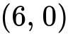 , and the y-intercept is at 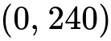 .
Write down 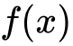 in the form 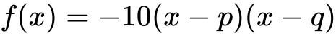 .
11b. [4 marks]
Find another expression for in the form 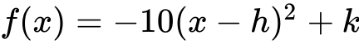 .
11c. [2 marks]
Show that can also be written in the form 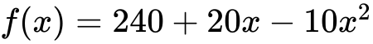 .
11d. [7 marks]
A particle moves along a straight line so that its velocity, 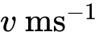 , at time t seconds is given by 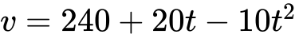 , for 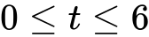 .
(i) Find the value of t when the speed of the particle is greatest.
(ii) Find the acceleration of the particle when its speed is zero.
12a. [2 marks]
Let 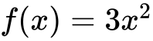 . The graph of f is translated 1 unit to the right and 2 units down. The graph of g is the image of the graph of f after this translation.
Write down the coordinates of the vertex of the graph of g .
12b. [2 marks]
Express g in the form 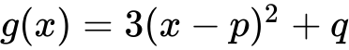 .
12c. [2 marks]
The graph of h is the reflection of the graph of g in the x-axis.
Write down the coordinates of the vertex of the graph of h .
13a. [3 marks]
Let 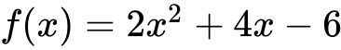 .
Express in the form 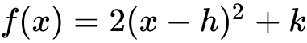 .
13b. [1 mark]
Write down the equation of the axis of symmetry of the graph of f .
13c. [2 marks]
Express in the form 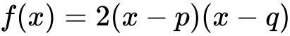 .

Printed for Pueblo East High School
© International Baccalaureate Organization 2018
International Baccalaureate® - Baccalauréat International® - Bachillerato Internacional®

