Summer Homework Ready for Year 2: __________________________________________________

For 2019-2020

Math Methods

**PAPER 1 – NO CALCULATOR ALLOWED**

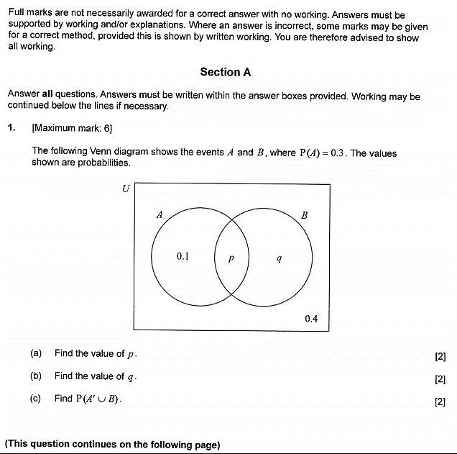

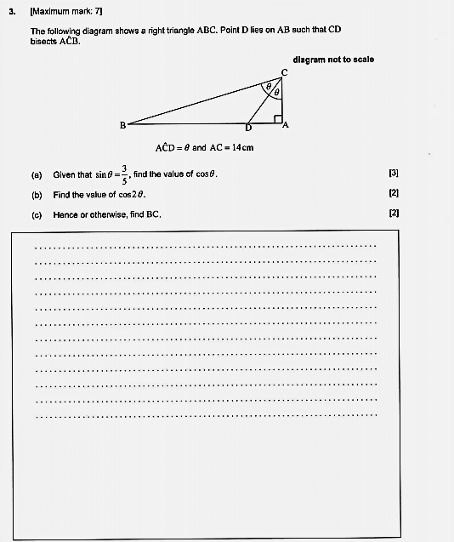

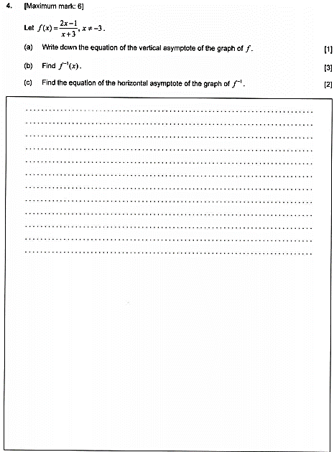

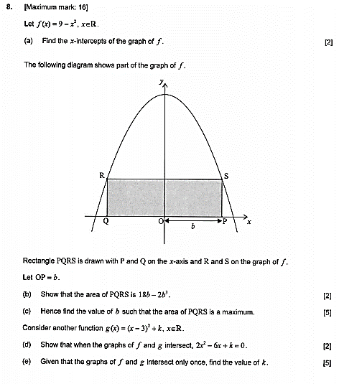

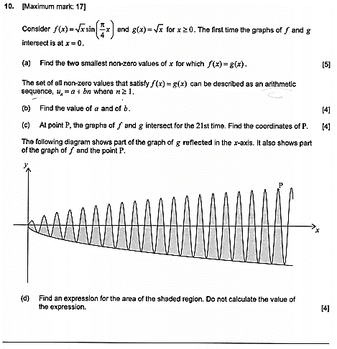

**PAPER 2 – CALCULUATOR ALLOWED**

